

|  |  |  |
| --- | --- | --- |
| **Name: SYED AQIL FARIHIN (AM2307013918)** | | |
| **Lecturer**  Nuri Surina binti Abdul Halim | | **Lab group / Tutorial group**  **/ Tutor (if applicable)**  SECTION 3 |
| **Course Code:**  (SWC2353) | | **Submission Date: 21**/11/2024 |
| **Project No. / Title:**  Final Assessment | | **Extension & Late**  **submission: ALLO WED /**  DISALLOWED |
| **Project type:Individual** | **% of Assignment**  **Mark** | **Returning Date:** |
| **Penalties:**   1. **10% of the original mark will be deducted for every one-week period after the submission date** 2. **No work will be accepted after two weeks of the deadline** 3. **If you were unable to submit the coursework on time due to extenuating circumstances you may be eligible for an extension** 4. **Extension will not exceed one week** | | |

**Declaration: I the undersigned confirm that I have read and agreed to abide by these**

**regulations on plagiarism and cheating. I confirm that this piece of work is my own. I**

**consent to appropriate storage of my work for checking to ensure that there is no**

**pl**

**agiarism/ academic cheating.**

**Signature(s):**

**Full Name: (SYED AQIL)**

**This section may be used for feedback or other information:**



|  |  |
| --- | --- |
| Table of content | Pages |
| Project background |  |
| Problem statement |  |
| Objectives |  |
| Target user |  |
| Site’s organization |  |
| Screenshot of website |  |
| Github link |  |

**PROJECT BACKGROUND**

This project aims to develop an e-commerce platform that facilitates online transactions, product listings, and secure payment methods. The platform will cater to a target audience, offering them a smooth shopping experience with personalized product recommendations, quick search functionalities, and responsive customer support. Additionally, it will provide vendors with an efficient system to manage inventories, track sales, and analyze customer data.

**PROBLEM STATEMENT**

Despite the growth of eCommerce, many small and medium-sized businesses struggle to reach their target customers online due to limitations in budget, technical expertise, and platform reliability. Existing platforms may be costly, complicated to navigate, or lack the flexibility to meet unique business needs. This project aims to address these challenges by developing an affordable, easy-to-use eCommerce website that enables businesses to manage products, process secure transactions, and track inventory seamlessly. The platform will focus on providing a streamlined, responsive experience that is accessible across various devices, ensuring that businesses can effectively engage with their customers and scale their operations.

**OBJECTIVES**

**Develop an Affordable Platform**: Create a cost-effective eCommerce website tailored to small and medium-sized businesses, offering essential features without unnecessary expenses.

**User-Friendly Interface**: Design a simple and intuitive interface that enables users with minimal technical knowledge to easily navigate, manage products, and update inventory.

**Responsive and Accessible Design**: Ensure the platform is fully responsive, providing a seamless shopping experience across desktops, tablets, and mobile devices.

**Secure and Reliable Transactions**: Integrate secure payment processing to protect customer data and build trust in the online shopping process.

**Scalability**: Build the platform with a scalable infrastructure that can grow with business needs, supporting additional products, increased traffic, and feature expansions.

**Inventory and Order Management**: Enable real-time tracking of inventory and automated order updates to improve business efficiency and customer satisfaction

**TARGET USER**

* Regular customer: Normal customer that always use e-commerce regularly
* Elderly: Many elderly people find it hard to use some of the e-commerce website.So this website can help these people as it is easy to use.
* Parent or teenagers: On this website, the price will be lower compare to the other.

**SITE’S ORGANIZATION**

* Home page: User can take a look at product available.
* About page: This page show user why I create this website and my mission.
* Features page: This page show user what features can be found in this website.
* Men’s section: This page allow user to search for men’s product and user can buy product from here.
* Women’s section: This page allow user to search for women’s product and user can buy product from here.
* Kid’s section: This page allow user to search for kid’s product and user can buy product from here. User also can find product for boy and girl.
* Accessories’s section: This page allow user to search for accesories’s product and user can buy product from here.
* Contact page: This page allow user to send message to me and see my address, phone number, and email.

**SCREENSHOT OF WEBSITE**

Home Page: 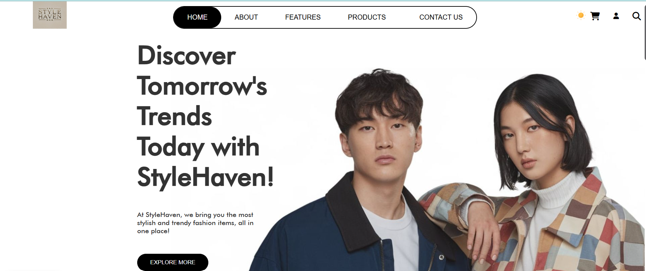

This Is the top page of the home page. On the header, user can access to about page, features page, and contact page.

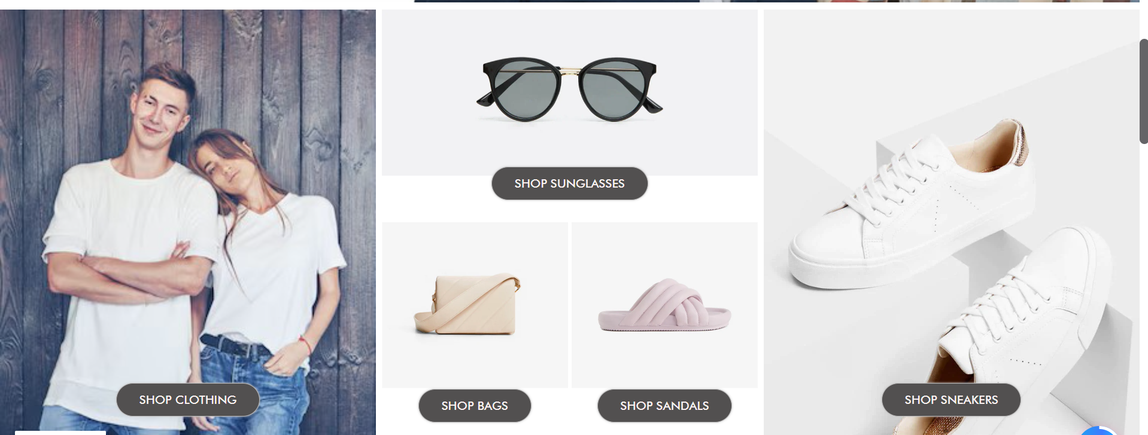

This is the middle of the home page. Here, user can access to our product such as clothing, sunglasses, bags, sandals, and sneakers.



This is the bottom of the home page. User can access quick links to about us and contact. Most of the website page has the same footer.

About page:

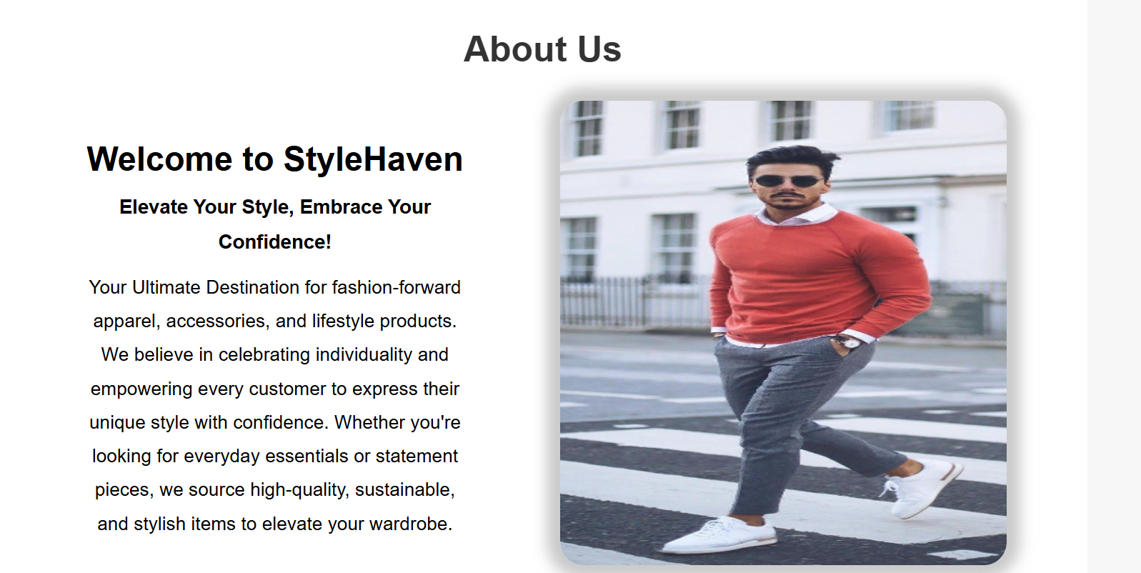

This is the about page. User can read why I create this website and what the website has to offer.

Features page:

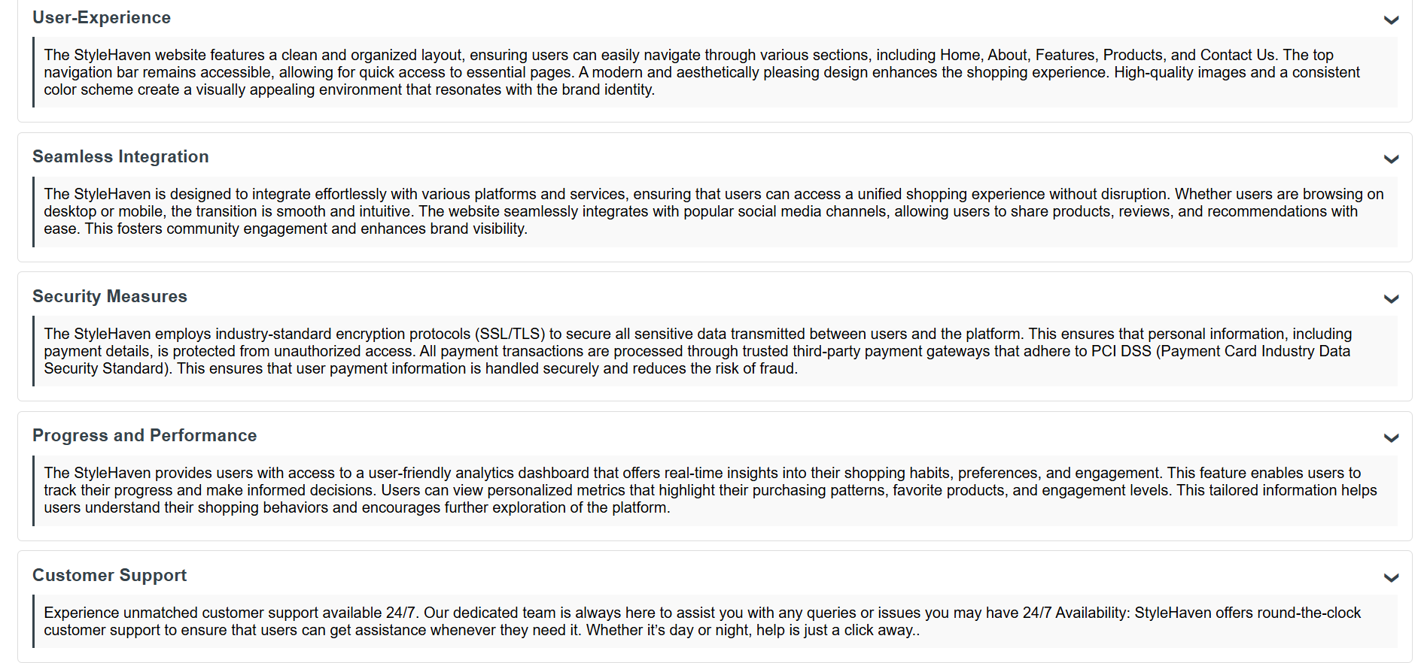

This is the features page. User can know what features available on the website.

Product page:

On product page, there are four categories where the user can find the item that they like.

Men product: 

User can search by categories for easy search.

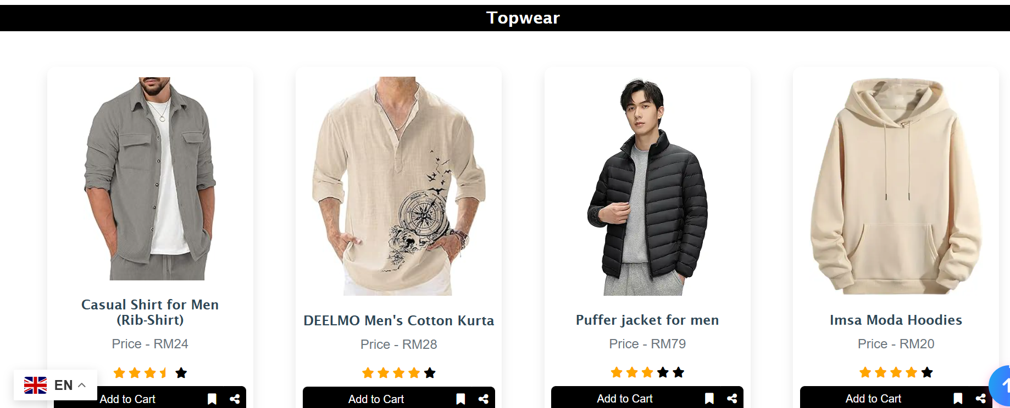

User can find various topwear product.

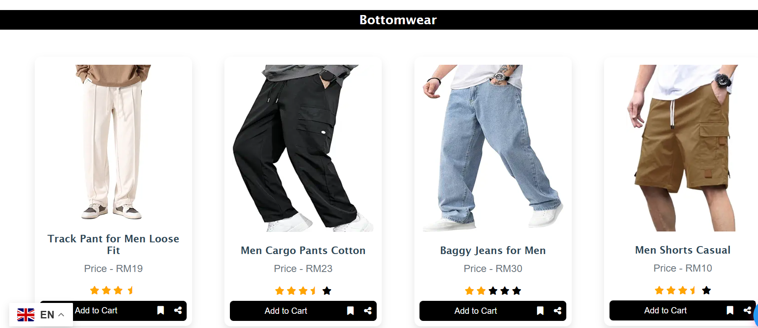

User can find various bottomwear products.

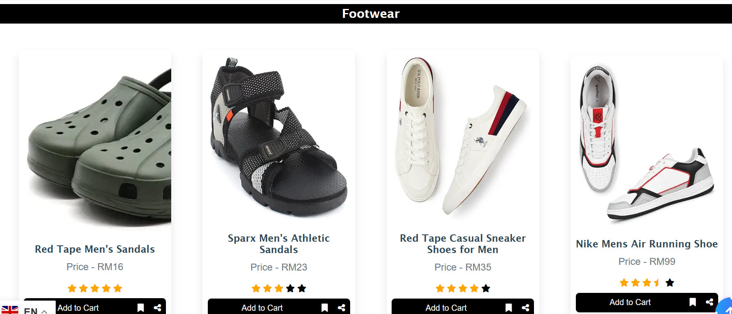

User can find various footwear products.

Women products:

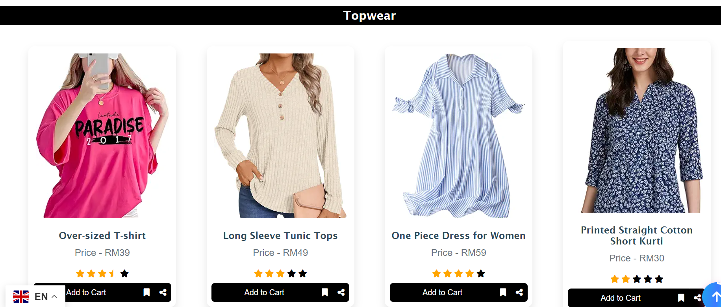

User can find various topwear products.

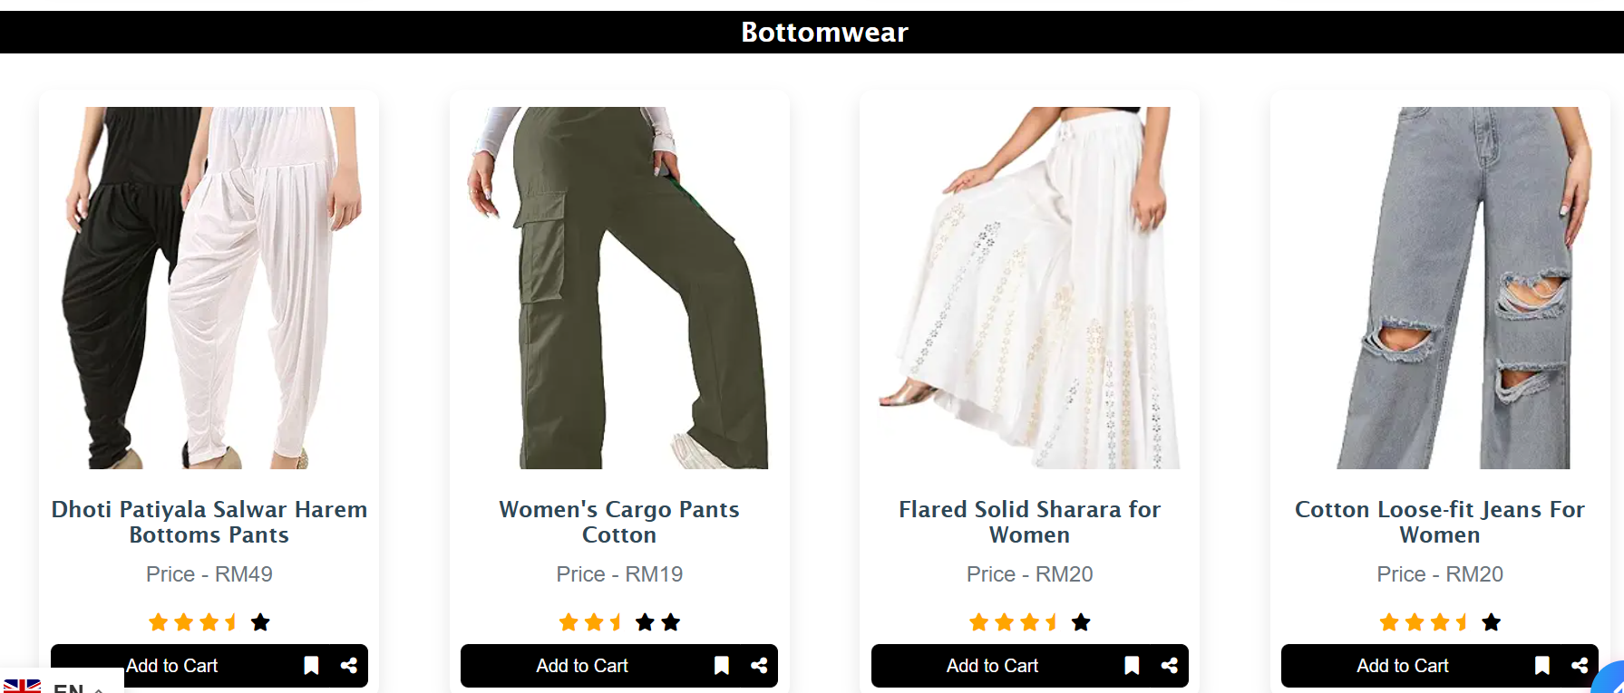

User can find various bottomwear products.

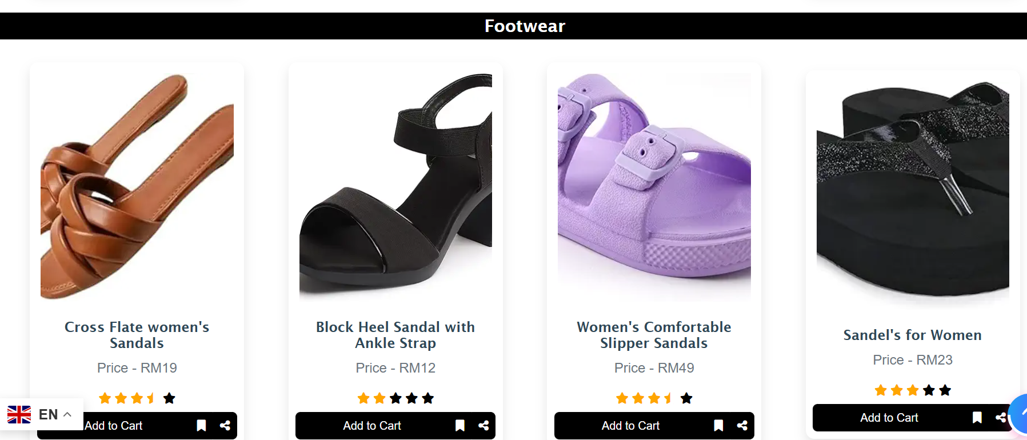

User can find various footwear products.

Contact page:

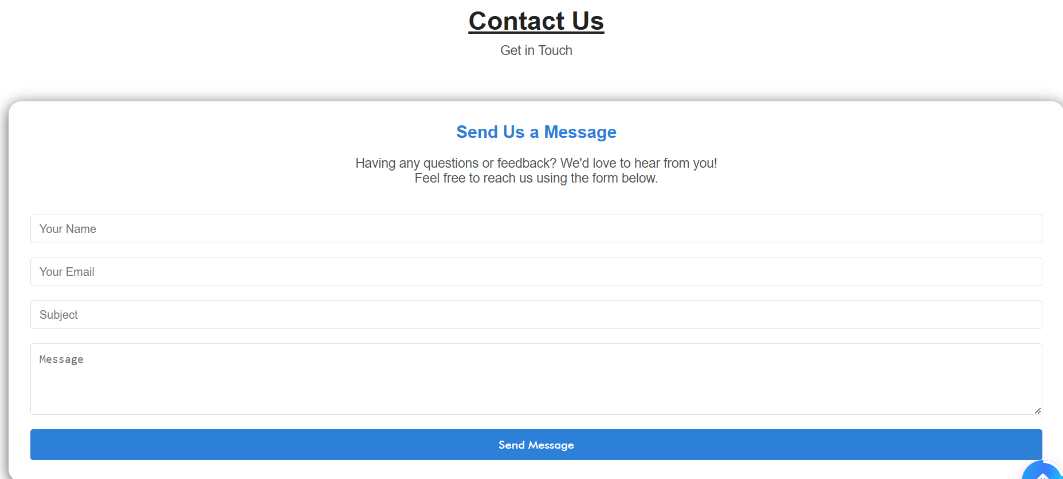

User can send messages.

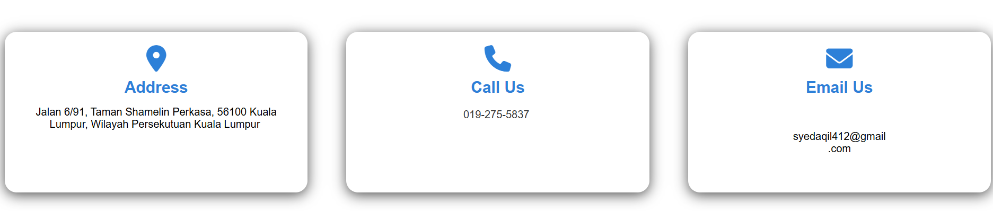

User can see the address, phone number, and email to contact me.

GITHUB LINK: